Mummies for Dummies
Step by Step Guide for Mummification
Goal:  To ensure the body reaches the afterlife. |  | Materials List:  - Linen -  - Wire hook -  - -  - -  - -
Steps | How | Why | Image
1 | Wash the body with water from the Nile River and palm wine. | The body needs to be purified ready for the next step. | 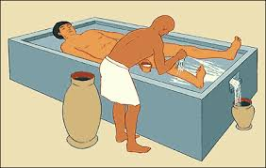
2
3
4
5
6
7
8
9
10

